1. Navigate to the CPR folder on the Bridge EVM sharepoint site.

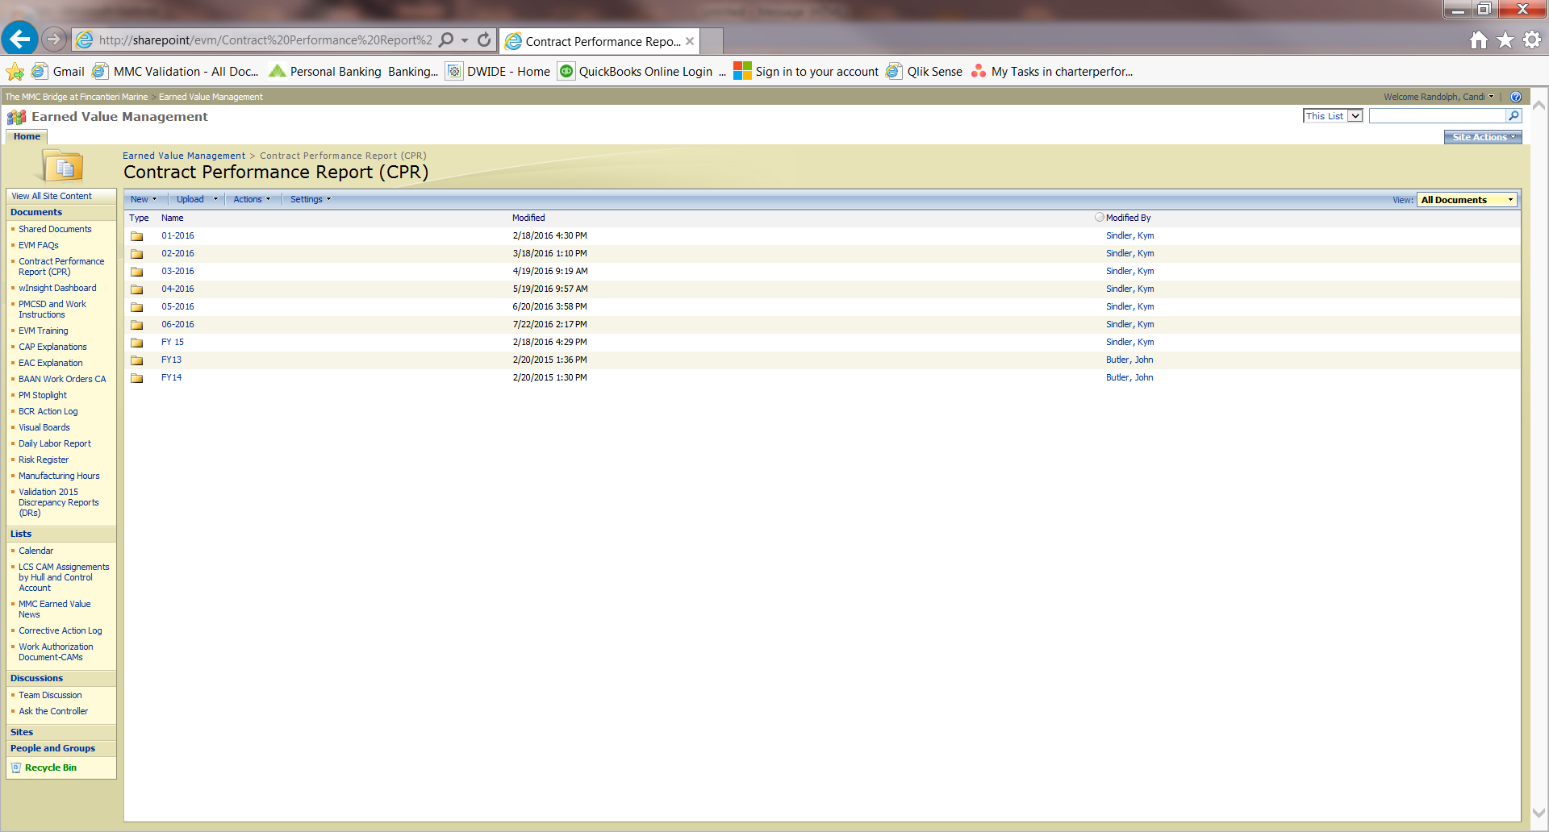

1. Open the folder with Windows Explorer.

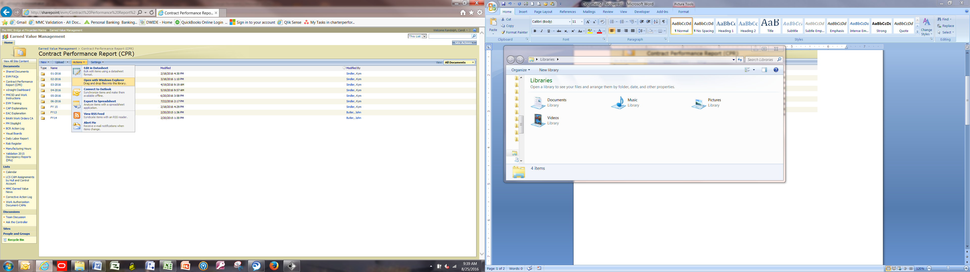

1. If you are the first to post your CPRs, create a folder for the period using the naming convention mo-yyyy.

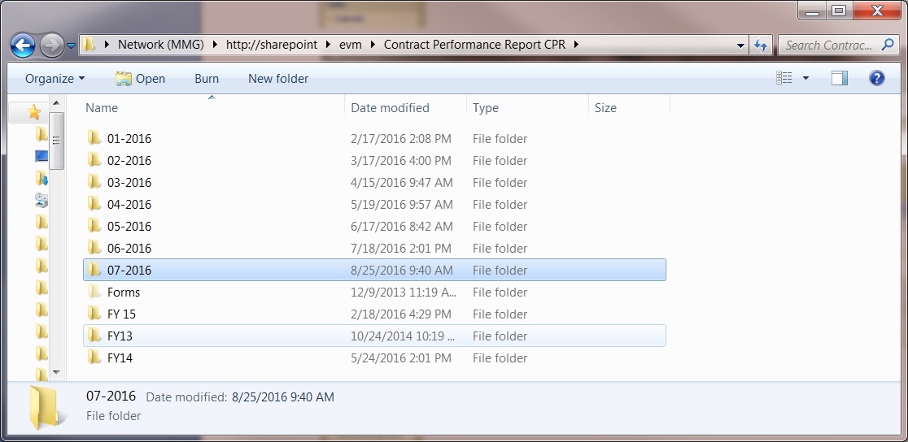

1. Create a folder for your CPRs using the program ID.

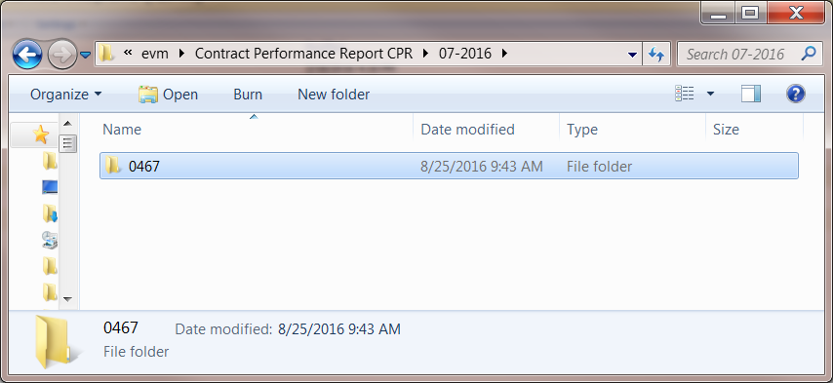

1. Post your CPRs.

